

DEPARTMENT OF ARTIFICIAL INTELLIGENCE AND MACHINE LEARNING

**WEB TECHNOLOGY Laboratory Course Code:21AIL63**

***Lab Manual***

Academic Year:2023-2024 BATCH: 2021 – 2025 YEAR: III

SEMESTER: VI

Lab-Coordinator: Mrs.Jimsha K Mathew

Mr.Syam Dev



**INSTITUTION**

# Vision

To emerge as an institute of eminence in the fields of engineering, technology and management in serving the industry and the nation by empowering students with a high degree of technical, managerial and practical competence.

# Mission

To strengthen the theoretical, practical and ethical dimensions of the learning process by fostering a culture of research and innovation among faculty members and students.

To encourage long-term interaction between the academia and industry through their involvement in the design of curriculum and its hands-on implementation.

To strengthen and mould students in professional, ethical, social and environmental dimensions by encouraging participation in co-curricular and extracurricular activities. To develop value based socially responsible professionals for the betterment of the society

# Quality Policy

To emerge as an institute of eminence in the fields of engineering, technology and management in serving the industry and the nation by empowering students with a high degree of technical, managerial and practical competence.

# Values

* Academic Freedom
* Innovation
* Integrity
* Professionalism
* Inclusiveness
* Social Responsibility



# DEPARTMENT of AI & ML

**Vision**

To develop an outstanding AI and ML professionals with profound practical, research & managerial skills to meet ever changing Industrial Social and Technological needs of the Society

# Mission

To disseminate strong theoretical and practical exposure to meet the emerging trends in the industry. To promote a freethinking environment with innovative research and teaching-learning pedagogy.

To develop value based socially responsible professionals with high degree of leadership skills will support for betterment of the society.

# Program Educational Objectives (PEOs)

**PEO1**

**PEO2**

**PEO3**

Develop and excel in their chosen profession on technical front and progress towards advanced continuing education or Inter-disciplinary Research and Entrepreneurship

Become a reputed innovative solution provider- to complex system problems or towards research or challenges relevant to Artificial Intelligence and Machine learning

Progress as skilled team members achieving leadership qualities with trust and professional ethics, pro-active citizens for progress and overall welfare of the society

[Type here]



# Program Specific Outcomes (PSOs)

**A graduate of the Computer Engineering Program will demonstrate**

**PSO1:** Develop models in Data Science, Machine learning, Deep learning and Bigdata technologies, using acquired AI knowledge and modern tools.

**PSO2:** Formulate solutions for interdisciplinary problems through acquired programming knowledge in the respective domains complying with real-time constraints.

# Program Outcomes (POs)

**PO1 Engineering knowledge:** Apply the knowledge of mathematics, science, Engineering fundamentals, and an Engineering specialization to the solution of complex Engineering problems in Computer Engineering.

**PO2 Problem analysis:** Identify, formulate, review research literature, and analyze complex Engineering problems in Computer Engineering reaching substantiated conclusions using first principles of mathematics, natural sciences, and Engineering sciences.

**PO3 Design / Development of Solutions:** Design solutions for complex Engineering problems and design system components or processes of Computer Engineering that meet the specified needs with appropriate consideration for the public health and safety, and the cultural, societal, and Environmental considerations.

**PO4 Conduct Investigations of Complex Problems:** Use research based knowledge and research methods including design of experiments in Computer Engineering, analysis and interpretation of data, and synthesis of the information to provide valid conclusions.

**PO5 Modern Tool Usage:** Create, select, and apply appropriate techniques, resources, and modern Engineering and IT tools including prediction and modeling to complex Engineering activities in Computer Engineering with an understanding of the limitations.

**PO6 The Engineer and Society:** Apply reasoning informed by the contextual knowledge to assess societal, health, safety, legal and cultural issues and the consequent responsibilities relevant to the professional engineering practice in Computer Engineering.

**PO7 Environment and Sustainability:** Understand the impact of the professional Engineering solutions of Computer Engineering in societal and Environmental contexts, demonstrate the knowledge of, and need for sustainable development.

**PO8 Ethics:** Apply ethical principles and commit to professional ethics, responsibilities, and norms of the Engineering practice.

**PO9 Individual and Team Work:** Function effectively as an individual, and as a member or leader in diverse teams, and in multidisciplinary settings.

**PO10 Communication Skills:** Communicate effectively on complex Engineering activities with the Engineering community and with society, such as, being able to comprehend and write effective reports and design documentation, make effective presentations, and give and receive clear instructions.

**PO11 Project Management and Finance:** Demonstrate knowledge and understanding of the Engineering and management principles and apply these to one’s own work, as a member and leader in a team, to manage projects and in multidisciplinary Environments.

**PO12 Life-long Learning:** Recognize the need for, and have the preparation and ability to engage in independent and life-long learning in the broadest context of technological change.

|  |  |  |  |  |  |  |  |  |  |  |  |  |  |  |  |  |  |  |  |  |
| --- | --- | --- | --- | --- | --- | --- | --- | --- | --- | --- | --- | --- | --- | --- | --- | --- | --- | --- | --- | --- |
| **WEB TECHNOLOGY LABORATORY** | | | | | | | | | | | | | | | | | | | | |
| **Course Code** | | | **21AIL63** | | | | | | | | **CIE Marks** | | | | | **50** | | | | |
| **L:T:P:S** | | | **0:0:1:0** | | | | | | | | **SEE Marks** | | | | | **50** | | | | |
| **Hrs. / Week** | | | **2** | | | | | | | | **Total Marks** | | | | | **100** | | | | |
| **Credits** | | | **01** | | | | | | | | **Exam Hours** | | | | | **03** | | | | |
| **Course outcomes:** At the end of the course, the student will be able to: | | | | | | | | | | | | | | | | | | | | |
| 21AIL63.1 | | Apply the concepts of HTML5, CSS, JavaScript, XML, PHP and develop Java Script programs | | | | | | | | | | | | | | | | | | |
| 21AIL63.2 | | Develop XML program to display student information using CSS. | | | | | | | | | | | | | | | | | | |
| 21AIL63.3 | | Analyse PHP program to keep of the number of visitors visiting the web page, Digital Clock, Simple calculator, matrix addition, Multiplication, transpose. | | | | | | | | | | | | | | | | | | |
| 21AIL63.4 | | Design the PHP programs to sort the student records in database using selection sort, string manipulations. | | | | | | | | | | | | | | | | | | |
| **Mapping of Course Outcomes to Program Outcomes and Program Specific Outcomes:** | | | | | | | | | | | | | | | | | | | | |
|  | | **PO1** | | **PO2** | **PO3** | **PO4** | **PO5** | **PO6** | **PO7** | **PO8** | | **PO9** | **PO10** | **PO11** | **PO12** | | | **PSO1** | | **PSO2** |
| 21AIL63.1 | | 3 | | - | - | - | **2** | - | - | - | | - | - | - | 2 | | | 3 | | - |
| 21AIL63.2 | | **3** | | **3** | 3 | - | 3 | - | - | - | | - | - | - | 2 | | | 3 | | - |
| 21AIL63.3 | | **3** | | 3 |  | - | 2 | - | - | - | | - | - | - | 2 | | | 3 | | - |
| 21AIL63.4 | | 3 | | 3 | 3 |  | 3 | - | - | - | | - | - | - | 2 | | | 3 | | - |
| **Ex. No** | **Experiments** | | | | | | | | | | | | | | | | **Hours** | | **COs** | |
|  | **Prerequisite Experiments / Programs / Demo** | | | | | | | | | | | | | | | |  | |  | |
|  | **Basics Programming Knowledge and HTML** | | | | | | | | | | | | | | | | **2** | | **NA** | |
| **Part A** | | | | | | | | | | | | | | | | | | | | |
| **1** | Design the following static web pages required for an online book store Home page: Must contain 3 frames 1) Login page 2) Catalogue page: Must contain all books details available in the store and 3) Registration page: | | | | | | | | | | | | | | | | **2** | | 21AIL63.1  21AIL63.2 | |
| **2** | Develop and demonstrate the usage of inline, internal and external style sheet using CSS. | | | | | | | | | | | | | | | | **2** | | 21AIL63.1  21AIL63.2 | |
| **3** | Write a JavaScript to design a simple calculator to perform the following operations: sum, product, difference and quotient. | | | | | | | | | | | | | | | | **2** | | 21AIL63.1  21AIL63.2 | |
| **4** | Write a JavaScript that calculates the squares and cubes of the numbers from 0 to 10 and outputs HTML text that displays the resulting values in an HTML table format. | | | | | | | | | | | | | | | | **2** | | 21AIL63.1  21AIL63.2  21AIL63.3 | |
| **5** | Write a JavaScript code that displays text “TEXT-GROWING” with increasing font size in the interval of 100ms in RED COLOR, when the font size reaches 50pt it displays “TEXT-SHRINKING” in BLUE color. Then the font size decreases to 5pt. | | | | | | | | | | | | | | | | **2** | | 21AIL63.1  21AIL63.2  21AIL63.3 | |
| **6** | Design an XML document to store information about a student in an engineering college affiliated to VTU. The information must include USN, Name, and Name of the College, Branch, Year of Joining, and email id. Make up sample data for 3 students. Create a CSS style sheet and use it to display the document. | | | | | | | | | | | | | | | | **2** | | 21AIL63.1  21AIL63.2  21AIL63.3 | |
| **PART B** | | | | | | | | | | | | | | | | | | | | |
| **7** | Write a PHP program to keep track of the number of visitors visiting the web page and to display this count of visitors, with proper headings. | | | | | | | | | | | | | | | | **2** | | 21AIL63.2  21AIL63.3  21AIL63.4 | |
| **8** | Write a PHP program to display a digital clock which displays the current time of the server | | | | | | | | | | | | | | | | **2** | | 21AIL63.2  21AIL63.3  21AIL63.4 | |
| **9** | Write the PHP programs to do the following:  a. Implement simple calculator operations. b. Find the transpose of a matrix.  c. Multiplication of two matrices. d. Addition of two matrices. | | | | | | | | | | | | | | | | **2** | | 21AIL63.2  21AIL63.3  21AIL63.4 | |
| **10** | Write a program to demonstrate working of ‹iframe› tag in HTML. | | | | | | | | | | | | | | | | **3** | | 21AIL63.1  21AIL63.2  21AIL63.3  21AIL63.4 | |
| **11** | Write a program to demonstrate working of ‹anchor› tag in HTML. | | | | | | | | | | | | | | | | **3** | | 21AIL63.1  21AIL63.2  21AIL63.3  21AIL63.4 | |
| **12** | Write a program to demonstrate the Node.js to print hello world. | | | | | | | | | | | | | | | | **3** | | 21AIL63.1  21AIL63.2  21AIL63.3  21AIL63.4 | |
|  | **PART C-Virtual Lab/ on-line Demo**  1.PHP Concepts: <https://nptelvideos.com/php/php_video_tutorials.php>  2.Node.js Tutorials: https://www.youtube.com/watch?v=f2EqECiTBL8 | | | | | | | | | | | | | | | |  | |  | |
| **CIE Assessment Pattern (50 Marks – Lab)**   |  |  |  |  | | --- | --- | --- | --- | | **RBT Levels** | | **Test (s)**  **(20)** | **Weekly Assessment**  **(30)** | | **L1** | **Remember** | **-** | **-** | | **L2** | **Understand** | 5 | 5 | | **L3** | **Apply** | 5 | 10 | | **L4** | **Analyze** | 10 | 10 | | **L5** | **Evaluate** | - | 5 | | **L6** | **Create** |  | - |   **SEE Assessment Pattern (50 Marks – Lab)**   |  |  |  | | --- | --- | --- | | **RBT Levels** | | **Exam Marks Distribution**  **(50)** | | **L1** | **Remember** | **-** | | **L2** | **Understand** | **10** | | **L3** | **Apply** | **10** | | **L4** | **Analyze** | **20** | | **L5** | **Evaluate** | **10** | | **L6** | **Create** | **-** |   **Suggested Learning Resources:**  **Reference Books:**  1. Good fellow,I.,Bengio,Y., and Courville,A.,DeepLearning,MITPress,2016.  2. SatishKumar, Neural Networks:A Class room Approach,TataMcGraw-HillEducation,2004.  **Reference Books:**  1. Yegnanarayana,B., Artificial Neural Networks PHI Learning Pvt. Ltd, 2009  2. Golub,G.,H.,andVanLoan,C.,F.,MatrixComputations,JHUPress,2013. | | | | | | | | | | | | | | | | | | | | |

## LAB RUBRICS

Internal Assessment Marks: 50

Divided into two components:

1. Continuous Assessment: 30 marks
2. Internal Test: 20 marks
3. Continuous Assessment:
   1. Will be carried out in every lab (for labs -30 programs)
   2. Each program will be evaluated for 30 marks
   3. Totally for 12 lab programs it will be 360 marks. This will be scaled down to 30.
   4. During the semester, 2 internal tests will be conducted for 20 marks each. The total 50 marks for the internal tests will be taken.

Break up of 30 marks (in every lab):

Will be carried out in every lab (for 12 lab programs)

|  |  |  |
| --- | --- | --- |
| Attributes | Descriptors | Scores |
| Program Write- up(10) | Complete program with proper variable naming, proper commenting | 10 |
| Complete program with not so proper variable naming, poor commenting | 8 |
| Incomplete code | 3 |
| Not written | 1 |
| Execution & Results (10) | Passes all specified test cases efficiently | 10 |
| Fails in some test cases | 8 |
| Incomplete execution | 2 |
| Viva Voce(5) | Answers correctly | 5 |

|  |  |  |
| --- | --- | --- |
|  | Answers satisfactorily | 1 |

|  |  |  |
| --- | --- | --- |
|  | Do not answer any question | 0 |
| Record completion and submission (5) | Submits in time and completed (during subsequent lab) | 5 |
| Fails to submit the record in time / incomplete submission | 0 |

1. Internal Test:

Break up of 20 marks (for each of the 2 internal tests) which is scaled down to 20 marks after the conduction of 2 internal tests:

The 1st lab internal will comprise of the first 6lab programs and the 2nd lab internal will comprise of the next 6 lab programs.

|  |  |  |
| --- | --- | --- |
| Attributes | Descriptors | Scores |
| Program Write- up(6) | Complete program with proper variable naming, proper commenting | 6 |
| Complete program with not so proper variable naming, poor commenting | 3-4 |
| Incomplete code | 1-2 |
| Not written | 0 |
| Execution & Results (10) | Passes all specified test cases efficiently | 10 |
| Fails in some test cases | 5-6 |
| Incomplete execution | 2 |
| Viva Voce(4) | Answers 100% questions correctly | 4 |
| Answers 75% questions correctly | 2-3 |
| Answers satisfactorily | 1-2 |
| Does not answer any question | 0 |

## SEE

Assessment Marks: 50

Session End Examination is conducted for 50 marks .

|  |  |  |
| --- | --- | --- |
| Attributes | Descriptors | Scores |
| Program Write- up(10) | Complete program with proper variable naming, proper commenting | 10 |
| Complete program with not so proper variable naming, poor commenting | 5-6 |
| Incomplete code | 1-2 |
| Not written | 0 |
| Execution & Results (30) | Passes all specified test cases efficiently | 30 |
| Fails in some test cases | 20-23 |
| Incomplete execution | 1-9 |
| Viva Voce(10) | Answers 100% questions correctly | 10 |
| Answers 75% questions correctly | 7-8 |
| Answers satisfactorily | 4-5 |
| Does not answer any question | 0 |

[Type here]

## Experiment No:1

Design the following static web pages required for an online book store

1. **Home page: Must contain 3 frames**
2. **Login page**
3. Catalogue page: Must contain all books details available in the store
4. Registration page

## Code:

A. HOME PAGE:

The static home page must contain three frames.

**Top frame :** Logo and the college name and links to Home page, Login page, Registration page, Catalogue page and Cart page (the description of these pages will be given below).

**Left frame :** At least four links for navigation, which will display the catalogue of respective links.For e.g.: When you click the link “IT” the catalogue for IT Books should be displayed in the Right frame.

**Right frame:** The pages to the links in the left frame must be loaded here. Initially this page contains description of the web site

# home.html:

<html>

<frameset rows="15%,9%,76%" bordercolor="pink">

<frameset cols="20%,80%" bordercolor="red">

<frame src="logo.html" scrolling="no">

<frame src="title.html" >

</frameset>

<frame src="menu.html" name="f2" scrolling="no">

<frameset cols="15%,85%" bordercolor="red">

<frame src=" branches.html" >

<frame src="homedes.html>

</frameset> </frameset>

</html>

## Output: home page

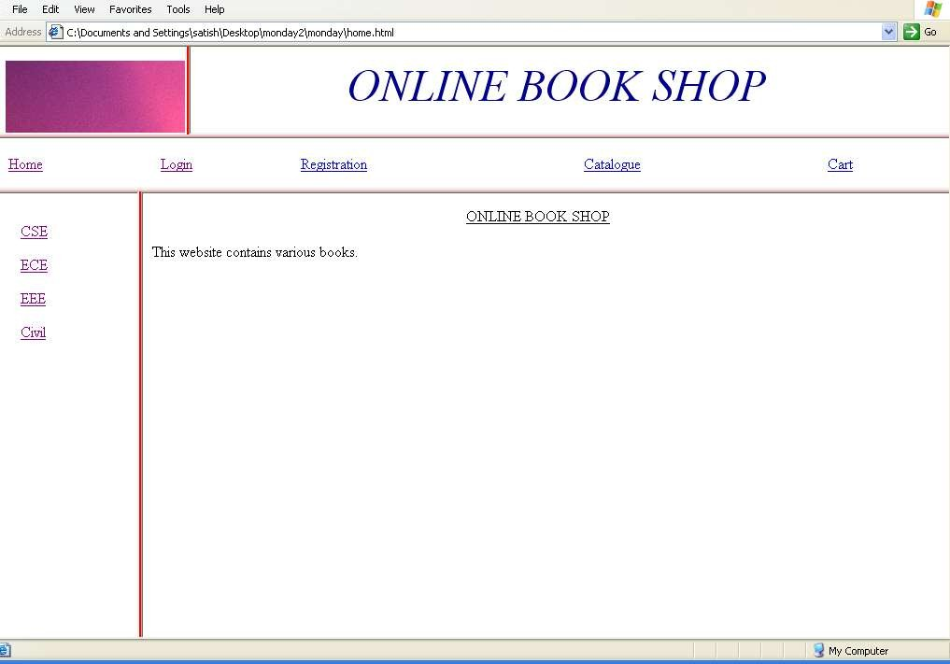

**logo.html**

<html>

<body>

<img src=" C:\Documents and Settings\satish\Desktop\monday2\monday\Sunset.jpg" >

</body>

**Title.html**

</html> title.html <html>

<body>

<center<i> ONLINE BOOK SHOP </i>

</font>

</center>

</body>

</html>

## branches.html

<html>

<table cellspacing=15>

<tr><td> <a href="csechecktest.html" CSE </a></td></tr>

<tr><td><a href="ecechecktest.html" >ECE </a> </td></tr>

<tr><td><a href="eeechecktest.html" >EEE </a></td></tr>

<tr><td><a href="civilchecktest.html" >Civil </a> </td></tr>

</table>

</body>

</html>

## Output: left frame

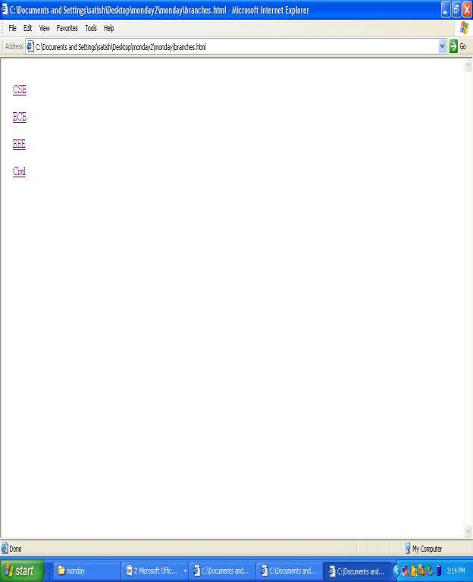

**menu.html**

<html>

<body>

<table width="100%">

<tr> <td> <a href="homedes.html" target="f32">Home </a></td>

<td> <a href="login.html" target="f32">Login </a></td>

<td> <a href="registration.html" target="f32">Registration</a></td>

<td> <a href="catalogue.html" target="f32">Catalogue </a></td>

<td> <a href="cart.html" target="f32">Cart </a></td>

</tr>

</table>

</body>

</html>

**homedes.html**

<html>

<body>

<center>

<u> ONLINE BOOK SHOP </u>

</center>

<p>This website contains various books.

</body>

</html>

**Output: top frame**

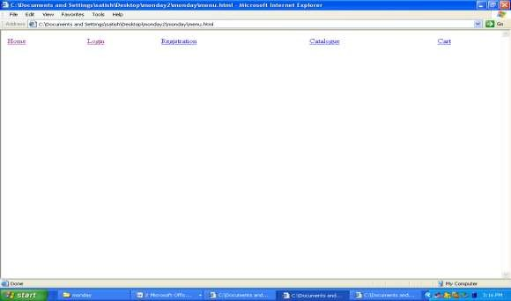

## login.html

<html>

<head>

<title> Login Page </title>

</head>

<body>

<form name="login">

<h3> <u> Login Page </u> </h3>

username: <input type="text" name="uname" >

<br>

password: <input type="password" name="pwd" >

<br>

<input type="submit" value="Submit" >

<input type="reset" value="reset">

</center>

</form>

</body>

</html>

**Output: login page(we will get this output when you click on login in home page)**

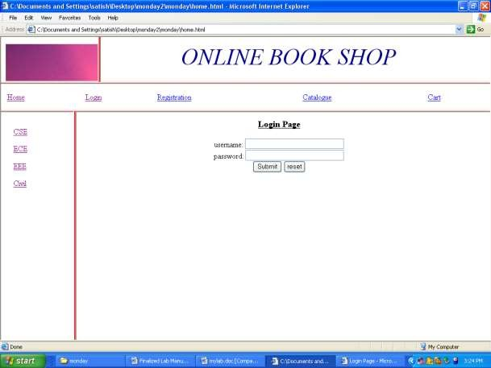

## catalogue.html

<HTML>

<HEAD>

<TITLE> lOADING xml dOCUMENT

</TITLE>

<SCRIPT LANGUAGE="JavaScript">

function fun()

{

window.alert("You have selected the book"); }

</SCRIPT>

</HEAD>

<BODY>

<SCRIPT LANGUAGE="JavaScript">

var xmldoc; xmldoc = new ActiveXObject("Microsoft.XMLDOM"); xmldoc.load("book.xml"); arr=xmldoc.getElementsByTagName("ITEM"); for(i=0;i<arr.length;i++)

{

document.write("<div align='left'>

<img src='Sunset.jpg' width='50' height='50'> </div>"); document.write("<div

align='center'><b>NAME:</b>"+xmldoc.getElementsByTagName("NAME")[i].childNodes[0]

.nodeValue+"<BR></div>"); document.write("<div

align='center'><b>AUTHOR:</b>"+xmldoc.getElementsByTagName("AUTHOR")[i].childNo des[0].nodeValue+"<BR></div>");

document.write("<div align='center'><b>PRICE:</b>"+xmldoc.getElementsByTagName("PRICE")[i].childNodes[0]. nodeValue+"<BR></div>");

document.write("<div align='center'><b>PUBLISHER:</b>"+xmldoc.getElementsByTagName("PUBLISHER")[i].c hildNodes[0].nodeValue+"<BR></div>");

document.write("<div align='center'><b>ISBN:</b>"+xmldoc.getElementsByTagName("ISBN")[i].childNodes[0].no deValue+"<BR></div>");

document.write("<div align='right'><input type='button' value='Add To Cart' onclick='fun()'</div>"); document.write("<BR>");

}

</SCRIPT>

</BODY>

</HTML>

## book.xml

<?xml version="1.0"?>

<BOOK>

<ITEM>

<NAME> JAVA </NAME>

<AUTHOR> SCHIELD </AUTHOR>

<PRICE> 500 </PRICE>

<PUBLISHER> TATA </PUBLISHER>

<ISBN> 12345 </ISBN>

</ITEM>

<ITEM>

<NAME> C++ </NAME>

<AUTHOR> HERBERT </AUTHOR>

<PRICE> 499.99 </PRICE>

<PUBLISHER> TATA </PUBLISHER>

<ISBN> 12346 </ISBN>

</ITEM>

<ITEM>

<NAME> DigitalElectronics </NAME>

<AUTHOR> SCHIELD </AUTHOR>

<PRICE> 500 </PRICE>

<PUBLISHER> TATA </PUBLISHER>

<ISBN> 12345 </ISBN> </ITEM>

<ITEM>

</ITEM>

<NAME> opticalCommunication </NAME>

<AUTHOR> HERBERT </AUTHOR>

<PRICE> 499.99 </PRICE>

<PUBLISHER> TATA </PUBLISHER>

<ISBN> 12346 </ISBN>

</ITEM> <ITEM>

<NAME> Electric Theory1 </NAME>

<AUTHOR> SCHIELD </AUTHOR>

<PRICE> 500 </PRICE>

<PUBLISHER> TATA </PUBLISHER>

<ISBN> 12345 </ISBN>

<ITEM>

<NAME> Electric Theory2 </NAME>

<AUTHOR> HERBERT </AUTHOR>

<PRICE> 499.99 </PRICE>

<PUBLISHER> TATA </PUBLISHER>

<ISBN> 12346 </ISBN>

</ITEM>

<ITEM>

<NAME> CIVIL THEORY1 </NAME>

<AUTHOR> SCHIELD </AUTHOR>

<PRICE> 500 </PRICE>

<PUBLISHER> TATA </PUBLISHER>

<ISBN> 12345 </ISBN>

</ITEM>

<ITEM>

<NAME> CIVIL THEORY2 </NAME>

<AUTHOR> HERBERT </AUTHOR>

<PRICE> 499.99 </PRICE>

<PUBLISHER> TATA </PUBLISHER>

<ISBN> 12346 </ISBN>

</ITEM> </BOOK>

Output: Catalogue page

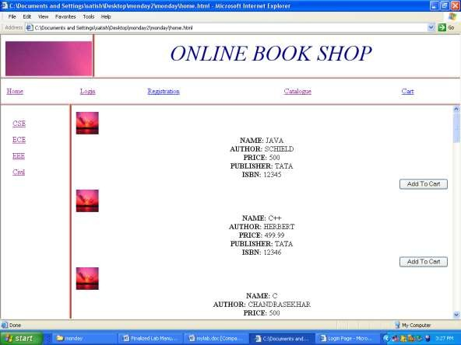

## csechecktest.html

<HTML>

<HEAD>

<TITLE> lOADING xml dOCUMENT

</TITLE> <SCRIPT LANGUAGE="JavaScript">

function fun() { window.alert("You have selected the book"); }

</SCRIPT>

</HEAD>

<BODY> <SCRIPT LANGUAGE="JavaScript">

var xmldoc; xmldoc = new ActiveXObject("Microsoft.XMLDOM"); xmldoc.load("csebook.xml"); arr=xmldoc.getElementsByTagName("ITEM");

for(i=0;i<arr.length;i++)

{

document.write("<div align='left'><img src='Sunset.jpg' width='50' height='50'>

</div>"); document.write("<div align='center'><b>NAME:</b>"+xmldoc.getElementsByTagName("NAME")[i].childNodes[0]

.nodeValue+"<BR></div>");

document.write("<div align='center'><b>AUTHOR:</b>"+xmldoc.getElementsByTagName("AUTHOR")[i].childNo des[0].nodeValue+"<BR></div>");

document.write("<div align='center'>

<b>PRICE:</b>"+xmldoc.getElementsByTagName("PRICE")[i].childNodes[0].no deValue+"<BR></div>");

document.write("<div align='center'><b>PUBLISHER:</b>"+xmldoc.getElementsByTagName("PUBLISHER")[i].c hildNodes[0].nodeValue+"<BR></div>");

document.write("<div align='center'><b>ISBN:</b>"+xmldoc.getElementsByTagName("ISBN")[i].childNodes[0].no deValue+"<BR></div>");

document.write("<div align='right'><input type='button' value='Add To Cart' onclick='fun()'</div>"); document.write("<BR>");

}

</SCRIPT></BODY></HTML>

## casebook.xml

<?xml version="1.0"?>

<CSEBOOK>

<ITEM>

<NAME> JAVA </NAME>

<AUTHOR> SCHIELD </AUTHOR>

<PRICE> 500 </PRICE>

<PUBLISHER> TATA </PUBLISHER>

<ISBN> 12345 </ISBN>

</ITEM>

<ITEM>

<NAME> C++ </NAME>

<AUTHOR> HERBERT </AUTHOR>

<PRICE> 499.99 </PRICE>

<PUBLISHER> TATA </PUBLISHER>

<ISBN> 12346 </ISBN>

</ITEM></CSEBOOK>

frame)

Output: right frame(we will get this output when we click on cse which was in left

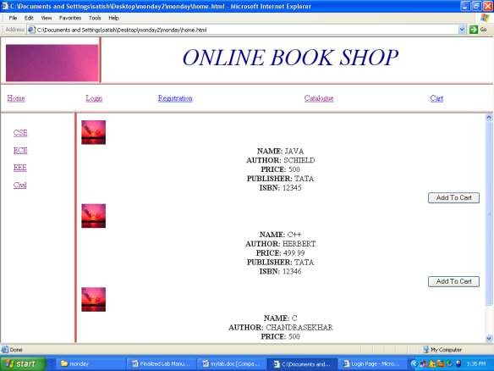

## ecechecktest.html

<HTML>

<HEAD> <TITLE> lOADING xml dOCUMENT </TITLE>

<SCRIPT LANGUAGE="JavaScript">

function fun()

{

window.alert("You have selected the book"); }

</SCRIPT>

</HEAD>

<BODY>

<SCRIPT LANGUAGE="JavaScript">

var xmldoc;

xmldoc = new ActiveXObject("Microsoft.XMLDOM"); xmldoc.load("ecebook.xml"); arr=xmldoc.getElementsByTagName("ITEM"); for(i=0;i<arr.length;i++)

{

document.write("<div align='left'>

<img src='Sunset.jpg' width='50' height='50'> </div>"); document.write("<div align='center'>

<b>NAME:</b>"+xmldoc.getElementsByTagName("NAME")[i].childNodes[0].no deValue+"<BR></div>");

document.write("<div align='center'><b>AUTHOR:</b>"+xmldoc.getElementsByTagName("AUTHOR")[i].childNo des[0].nodeValue+"<BR></div>");

document.write("<div align='center'><b>PRICE:</b>"+xmldoc.getElementsByTagName("PRICE")[i].childNodes[0]. nodeValue+"<BR></div>");

document.write("<div align='center'><b>PUBLISHER:</b>"+xmldoc.getElementsByTagName("PUBLISHER")[i].c hildNodes[0].nodeValue+"<BR></div>");

document.write("<div align='center'><b>ISBN:</b>"+xmldoc.getElementsByTagName("ISBN")[i].childNodes[0].no deValue+"<BR></div>");

document.write("<div align='right'><input type='button' value='Add To Cart' onclick='fun()'</div>"); document.write("<BR>");

}

</SCRIPT>

</BODY>

</HTML>

## ecebook.xml

<?xml version="1.0"?>

<ECEBOOK>

<ITEM>

<NAME> DigitalElectronics </NAME>

<AUTHOR> SCHIELD </AUTHOR>

<PRICE> 500 </PRICE>

<PUBLISHER> TATA </PUBLISHER>

<ISBN> 12345 </ISBN> </ITEM>

<ITEM> <NAME> opticalCommunication </NAME>

<AUTHOR> HERBERT </AUTHOR>

<PRICE> 499.99 </PRICE>

<PUBLISHER> TATA </PUBLISHER>

<ISBN> 12346 </ISBN></ITEM>

</ECEBOOK>

## Creating the cart page and registration pages.

**cart.html**

<html>

<body >

<table cellspacing="50" cellpadding="20">

<tr> <td>Book name</td>

<td>price</td>

<td>quantity</td>

<td>amount</td>

</tr> <tr>

<td>java2</td>

<td>$35.5</td>

<td>2</td>

<td>$70</td>

</tr>

<tr> <td>XML bible</td>

<td>$40.5</td>

<td>1</td>

<td>$40.5</td>

</tr>

<tr>

<td></td>

<td></td>

<td>Total amount </td>

<td>130.5 </td>

</tr>

</body>

</html>

Output:

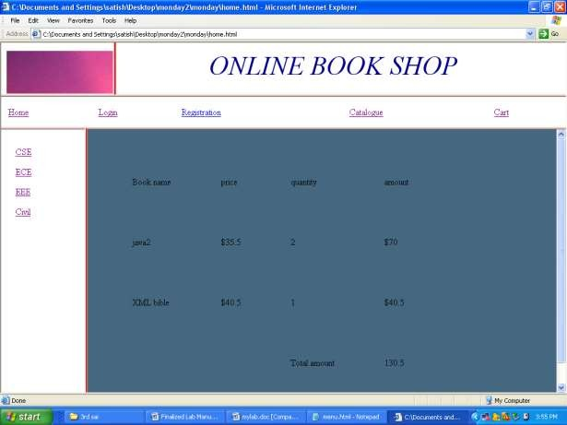

## Experiment No:2

Develop and demonstrate the use of Inline, Internal, External style sheets using CSS.

## Inline Style sheet

<!DOCTYPE html>

<html>

<body>

<h1 style="color:blue;text-align:center;">This is a heading</h1>

<p style="color:red;">This is a paragraph.</p>

</body>

</html>

## Internal style sheet

<!DOCTYPE html>

<html>

<head>

<style> body {

background-color: linen;

}

h1 {

color: maroon; margin-left: 40px;

}

</style>

</head>

<body>

<h1>This is a heading</h1>

<p>This is a paragraph.</p>

</body>

</html>

## External style sheets

<!DOCTYPE html>

<html>

<head>

<link rel="stylesheet" href="mystyle.css">

</head>

<body>

<h1>This is a heading</h1>

<p>This is a paragraph.</p>

</body>

</html>

## mystyle.css

body {

background-color: lightblue;

}

h1 {

color: navy; margin-left: 20px;

}

## Experiment No:3

Write a JavaScript to design a simple calculator to perform the following operations: sum, product, difference and quotient.

## Code:

<!DOCTYPE html>

<html lang="en">

<head>

<title>Simple Calculator</title>

<script type="text/javascript">

var op1=0,op2=0,operator="",res="",from="";

function reset()

{

document.getElementById('res').value = ""; op1=0;op2=0;operator="";res="";from="";

}

function insertOperand(operand)

{

else if(from == "operator")

if(from == "calculate") reset();

document.getElementById('res').value = ""; document.getElementById('res').value+=operand;

from = "operand";

}

function insertOperator(op)

{

if(op1 == 0)

{

}

else

{

op1=document.getElementById('res').value;

if(from == "operand")

{

calculate();

}

}

operator=op; from="operator";

}

function calculate()

{

op2=document.getElementById('res').value; op1=parseInt(op1);

op2=parseInt(op2); switch (operator)

{

case '+':res=op1+op2; break;

case '-':res=op1-op2; break;

case '*':res=op1*op2; break;

case '/':if(op2 == 0)

res=0;

else

break;

}

res=parseInt(op1/op2);

}

</script>

document.getElementById('res').value=res; op1=res;

op2=0; operator=""; from="calculate";

<style type="text/css">

input {width: 100%} h1 {text-align: center}

</style>

</head>

<body onload="reset()">

<h1>Simple Calculator</h1>

<table align="center" border="1">

<tr>

value="" /></td>

</tr>

<tr>

<td colspan="5"><input type="text" id="res" name="res"

<td><input type="button" value="7"

onclick="insertOperand('7')"/></td>

<td><input type="button" value="8" onclick="insertOperand('8')" /></td>

<td><input type="button" value="9" onclick="insertOperand('9')" /></td>

<td><input type="button" value="+" onclick="insertOperator('+')" /></td>

<td><input type="button" value="-" onclick="insertOperator('-')" /></td>

</tr>

<tr>

<td><input type="button" value="4"

onclick="insertOperand('4')" /></td>

<td><input type="button" value="5" onclick="insertOperand('5')" /></td>

<td><input type="button" value="6" onclick="insertOperand('6')" /></td>

<td><input type="button" value="*" onclick="insertOperator('*')" /></td>

<td><input type="button" value="/" onclick="insertOperator('/')"/></td>

</tr>

<tr>

<td><input type="button" value="1" onclick="insertOperand('1')" /></td>

<td><input type="button" value="2" onclick="insertOperand('2')" /></td>

<td><input type="button" value="3" onclick="insertOperand('3')" /></td>

<td><input type="button" value="0" onclick="insertOperand('0')" /></td>

<td><input type="button" value="=" onclick="calculate()"

/></td>

</tr>

<tr>

<td colspan="5"><input type="button" size="100%"

value="CLEAR" onclick="reset()"/> </td>

</tr>

</table>

</body>

</html>

Output:

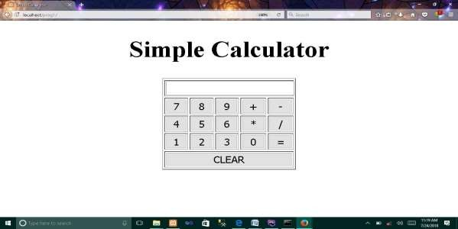

Experiment No:4

Write a JavaScript that calculates the squares and cubes of the numbers from 0 to 10 and outputs HTML text that displays the resulting values in an HTML table format.

**Code:**

<!DOCTYPE html>

<html lang="en">

<head>

<meta charset="UTF-8">

<title>Program for Squares and Cubes</title>

<style type="text/css">

table,h1 {text-align: center}

</style>

</head>

<body>

<h1>Program to find Square and Cube</h1>

<script type="text/javascript">

var mytable="<table border='1' align='center'> <tr> <th>Number</th>

<th>Square</th> <th>Cube</th> </tr>";

var square= 0,cube=0; for(var i=0;i<=10;i++)

{

square=i*i; cube=i*i*i;

mytable+="<tr><td>"+i+"</td><td>"+square+"</td><td>"+cube+"</td></tr>"

}

mytable+="</table>"; document.write(mytable);

</script>

</body>

</html>

Output:

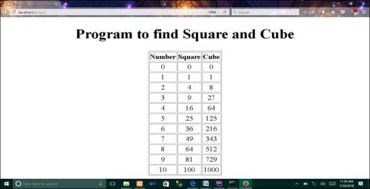

## Experiment No:5

Write a JavaScript code that displays text “TEXT-GROWING” with increasing font size in the interval of

100ms in RED COLOR, when the font size reaches 50pt it displays “TEXT-SHRINKING” in BLUE color. Then the font size decreases to 5pt.

**Code:**

## index.html

<!DOCTYPE html>

<html lang="en">

<head>

<meta charset="UTF-8">

<title>Prog for Text Animation</title>

<script type="text/javascript"> function animate()

{

var val=window.getComputedStyle(document.getElementById('text')).fontSize;

var fontsize=parseInt(val); var state="growing";

var timer=setInterval(textanimate,100); function textanimate()

{

if(state=="growing")

{

GROWING";

fontsize++; document.getElementById('text').innerHTML="TEXT

document.getElementById('text').style.color="red";

document.getElementById('text').style.fontSize=fontsize+"pt";

}

if(state=="shrinking")

{

SHRINKING";

fontsize--; document.getElementById('text').innerHTML="TEXT

document.getElementById('text').style.color="blue";

document.getElementById('text').style.fontSize=fontsize+"pt";

}

if(fontsize==50)

{

state="shrinking"

}

if(fontsize==5)

{

clearInterval(timer);

}

}

}

</script>

<body onload="animate()">

<h1 style="text-align: center">Program for Increasing / Decreasing size of a text </h1>

<p style="text-align: center;" id="text"></p>

</body>

</html>

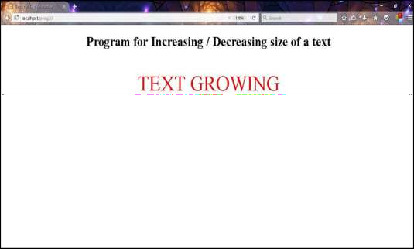Output:

* 1. Animation for textgrowing

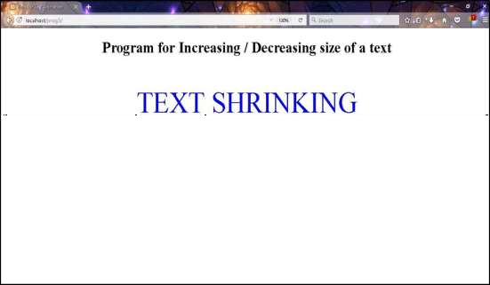

* 1. Animation for textshrinking

**Experiment No:6**

Design an XML document to store information about a student in an engineering college affiliated to VTU.The information must include USN, Name, and Name of the College, Branch, Year of Joining, and email id. Make up sample data for 3 students. Create a CSS style sheet and use it to display the document.

## Code.xml

<?xml version="1.0" encoding="UTF-8"?>

<?xml-stylesheet type="text/css" href="student.css"?>

<students>

<student>

<sname>Ankush</sname>

<usn>4SF15CS001</usn>

<college>SCEM</college>

<branch>CSE</branch>

<yoj>2015</yoj>

<e[mail>Ankush@xy](mailto:Ankush@xyz.com)z.com</email>

</student>

<student>

<sname>Rayan</sname>

<usn>4SF15CS003</usn>

<college>SCEM</college>

<branch>CSE</branch>

<yoj>2015</yoj>

<e[mail>Ra](mailto:Rayan@xyz.com)yan[@xyz](mailto:Rayan@xyz.com).c[om</e](mailto:Rayan@xyz.com)mail>

</student>

<student>

<sname>Pavan</sname>

<usn>4SF15CS006</usn>

<college>SCEM</college>

<branch>CSE</branch>

<yoj>2015</yoj>

<e[mail>Pava](mailto:Pavan@xyz.com)n@xyz[.com](mailto:Pavan@xyz.com)</email>

</student>

</students>

## student.css

students

{

background-color: pink; font-family: ‘cambria';

}

student

{

display: block; margin-bottom: 30pt; margin-left: 0;

}

sname

{

display: block; font-size: 15pt;

text-transform: uppercase; color: blue;

}

usn:before

{

}

usn

{

}

content: "USN: "; font-size: 14pt; font-weight: bold;

display: block; font-size: 14pt; margin-left: 20pt;

text-transform: uppercase; color: blueviolet;

college:before

{

content: "Affiliated College: "; font-size: 14pt;

font-weight: bold;

}

college

{

display: block; font-size: 14pt; margin-left: 20pt; color: blueviolet;

}

branch:before

{

content: "Branch: "; font-size: 14pt;

font-weight: bold;

}

branch

{

display: block; font-size: 14pt; margin-left: 20pt; color: blueviolet;

}

yoj:before

{

}

yoj

{

}

content: "Year of Joining: "; font-size: 14pt;

font-weight: bold;

display: block; font-size: 14pt; margin-left: 20pt; color: blueviolet;

email:before

{

content: "EMAILID: "; font-size: 14pt;

font-weight: bold;

}

email

{

display: block; font-size: 14pt; margin-left: 20pt; color: blueviolet;

}

Output:

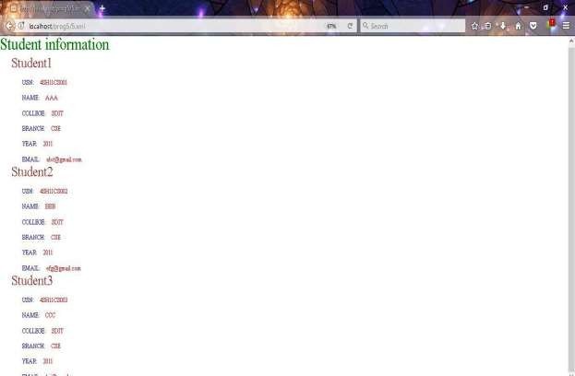

**Experiment No:7**

Write a PHP program to keep track of the number of visitors visiting the web page and to display this count of visitors, with proper headings.

**Code:**

## index.php

<html>

<head>

<title>Visitors Count</title>

<style type="text/css">

h1,h2 {text-align: center}

</style>

</head>

<body>

<h1>Welcome to MY WEB PAGE</h1>

<?php

?>

</body>

</html>

**Output:**

$file="count.txt";

$handle=fopen($file,'r') or die("Cannot Open File : $file");

$count=fread($handle,10); fclose($handle);

$count++;

echo "<h2>No of visitors who visited this page : $count </h2>";

$handle=fopen($file,'w') or die("Cannot Open File : $file"); fwrite($handle,$count);

fclose($handle);

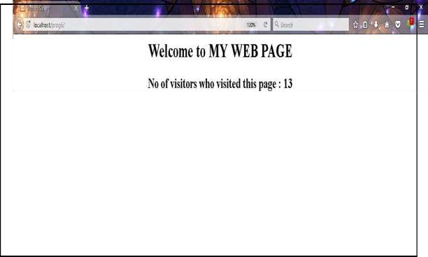

**Experiment No:8**

Write a PHP program to display a digital clock which displays the current time of the server.

## index.php

<html>

<head>

<meta http-equiv="refresh" content="1">

<title>Digital Clock</title>

<style type="text/css">

h1 {text-align: center}

</style>

</head>

<body>

<?php

echo "<h1>Digital Clock</h1>"; echo "<hr/>";

echo "<h1>".date('h:i:s A')."</h1>"; echo "<hr/>";

?>

</body>

</html>

**Output**

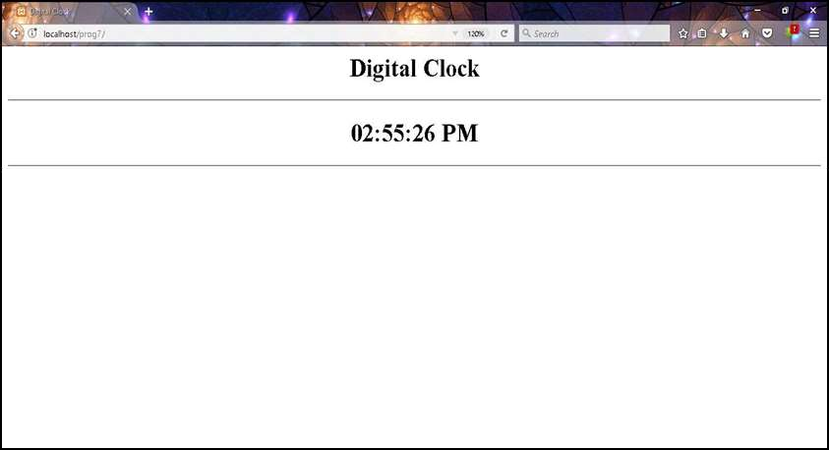

**Experiment No:9**

Write the PHP programs to do the following:

1. Implement simple calculator operations.
2. Find the transpose of a matrix.
3. Multiplication of two matrices.
4. Addition of two matrices.

**Code:**

## 9a.html

<!DOCTYPE html>

<html lang="en">

<head>

<meta charset="UTF-8">

<title>Simple Calculator</title>

</head>

<body>

<form action="9a.php" method="post">

<h1>Simple Calculator</h1>

<p>First Operand: <input type="text" name="op1" /></p>

<p>Choose Operator:

<input type="radio" name="operator" checked="checked"

value="+" />

</p>

Add(+)

<input type="radio" name="operator" value="-" /> Subtract(-)

<input type="radio" name="operator" value="*" /> Multiply(*)

<input type="radio" name="operator" value="/" /> Divide(/)

<p>Second Operand: <input type="text" name="op2"></p>

<p>

</html>

</p>

</form>

</body>

<input type="submit" name="submit" value="Submit">

<input type="reset" name="reset" value="Reset">

<html>

<head>

<title>Result Page</title>

<style type="text/css"> h1,h2 {text-align: center}

</style>

</head>

<body>

<?php

$op1=$_POST['op1'];

$op2=$_POST['op2'];

$operator=$_POST['operator']; switch($operator)

{

## 9a.php

case '+':$res=$op1+$op2;

break;

case '-':$res=$op1-$op2; break;

case '*':$res=$op1*$op2;

break;

case '/':if($op2==0)

{

}

else break;

echo "divide by zero error"; exit;

$res=$op1/$op2;

}

echo "<h1>Simple Calculator</h1>";

echo "<h2>".$op1.$operator.$op2."=".$res."</h2>"; ?>

</body>

</html>

## 9b.php

<?php

$mat=Array(Array(1,2), Array(4,5),

Array(7,8)); //Initializing Array in PHP

$transpose=Array(); //Creating empty array in PHP

echo "<html><head><title>Matrix Transpose</title></head><body>"; echo "<h1>Matrix is:<br/>";

for($i = 0; $i < count($mat); $i++)

{

for ($j = 0; $j < count($mat[0]); $j++)

{

echo $mat[$i][$j] . " ";

}

echo "</br/>";

}

echo "</h1>";

for($i = 0; $i < count($mat); $i++) //calculation for Transpose

for($j = 0; $j < count($mat[0]); $j++)

{

$transpose[$j][$i]=$mat[$i][$j];

}

echo "<h1>Transpose of a Matrix is:<br/>"; for($i = 0; $i < count($transpose); $i++)

{

for ($j = 0; $j < count($transpose[0]); $j++)

{

echo $transpose[$i][$j] . " ";

}

echo "<br/>";

}

echo "</h1>";

echo "</body></html>";

?>

<?php

## 9c.php

$mat1=Array(Array(1,2), Array(3,4), Array(5,6)); //initializing 2x3 matrix

$mat2=Array(Array(2,4,8), Array(1,3,5));//initializing 3x2 matrix

echo "<html><head><title>Matrix Multiplication</title></head><body>"; if(count($mat1[0])!=count($mat2)) //column(1st matrix) != row(2nd matrix)

{

echo "<h1>Incompatible Matrices</h1>"; exit(0);

}

$res=array();

echo "<h1>Matrix A:<br/>";

for($i = 0; $i < count($mat1); $i++)

{

for ($j = 0; $j < count($mat1[0]); $j++)

{

echo $mat1[$i][$j] . " ";

}

echo "<br/>";

}

echo "</h1>";

echo "<h1>Matrix B:<br/>";

for($i = 0; $i < count($mat2); $i++)

{

for ($j = 0; $j < count($mat2[0]); $j++)

{

echo $mat2[$i][$j] . " ";

}

echo "<br/>";

}

echo "</h1>";

for($i = 0; $i < count($mat1); $i++) for($j = 0; $j < count($mat2[0]); $j++)

{

$res[$i][$j]=0; for($k=0;$k<count($mat2);$k++)

$res[$i][$j]=$res[$i][$j]+$mat1[$i][$k]*$mat2[$k][$j];

}

echo "<h1>A x B:<br/>";

for($i = 0; $i < count($res); $i++)

{

for ($j = 0; $j < count($res[0]); $j++)

{

echo $res[$i][$j] . " ";

}

echo "<br/>";

}

echo "</h1>";

echo "</body></html>";

?>

<?php

## 9d.php

$mat1=Array(Array(1,2),Array(3,4),Array(5,6));

$mat2=Array(Array(1,1),Array(2,2),Array(3,3));

echo "<html><head><title>Matrix Addition</title></head><body>"; if((count($mat1)!=count($mat2))||(count($mat1[0])!=count($mat2[0])))

{

echo "<h1>Incompatible Matrices</h1>"; exit(0);

}

echo "<h1>Matrix A:<br/>";

for($i=0;$i<count($mat1);$i++)

{

for ($j = 0; $j < count($mat1[0]); $j++)

{

echo $mat1[$i][$j] . " ";

}

echo "<br/>";

}

echo "</h1>";

echo "<h1>Matrix B:<br/>";

for($i = 0; $i < count($mat2); $i++)

{

for ($j = 0; $j < count($mat2[0]); $j++)

{

echo $mat2[$i][$j] . " ";

}

echo "<br/>";

}

echo "</h1>";

$res=array();

for($i = 0; $i < count($mat1); $i++) for($j = 0; $j < count($mat1[0]); $j++)

{

$res[$i][$j]=$mat1[$i][$j]+$mat2[$i][$j];

}

echo "<h1>A + B :<br/>";

for($i = 0; $i < count($res); $i++)

{

for ($j = 0; $j < count($res[0]); $j++)

{

echo $res[$i][$j] . " ";

}

echo "<br/>";

}

echo "</h1>";

?>

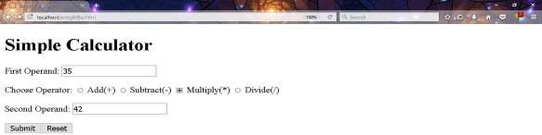

HTML input page

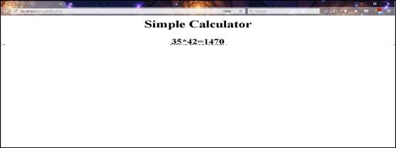

1. Simple calculator

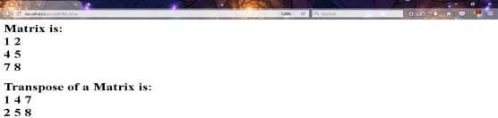

1. Transpose of a Matrix

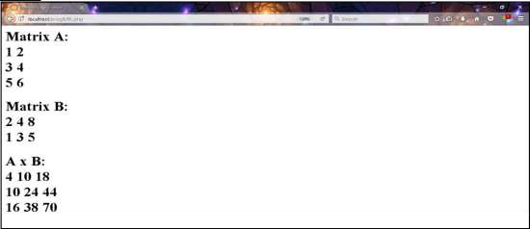

1. Multiplication of a matrix

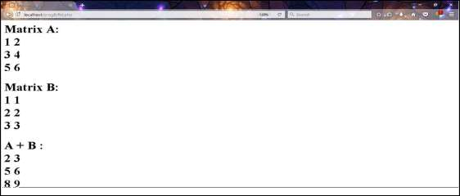

1. Addition of a matrix

**Experiment No:10**

**Write a program to demonstrate working of ‹iframe› tag in HTML**

**Program:**

<!DOCTYPE html>

<html>

<body>

<h2>HTML Iframes example</h2>

<p>Use the height and width attributes to specify the size of the iframe:</p>

<iframe src="https://newhorizoncollegeofengineering.in/" height="300" width="400"></iframe>

</body>

</html>

**Output:**



**Experiment No:11**

**Write a program to demonstrate working of ‹anchor› tag in HTML.**

Program:

<!DOCTYPE html>

<html>

<head>

<title></title>

</head>

<body>

<p>Click on <a href="https://newhorizoncollegeofengineering.in/" target="_blank"> this-link </a>to go on home page of NHCE.</p>

</body>

</html>

Output:



**Experiment No:12**

**Write a program to demonstrate the Node.js to print hello world.**

## [Step 1 — Outputting to the Console](https://www.digitalocean.com/community/tutorials/how-to-write-and-run-your-first-program-in-node-js#step-1-outputting-to-the-console)

To write a “Hello, World!” program, open up a command line text editor such as nano and create a new file:

***nano hello.js***

With the text editor opened, enter the following code:

***console.log("Hello World");***

## [Step 2 — Running the Program](https://www.digitalocean.com/community/tutorials/how-to-write-and-run-your-first-program-in-node-js#step-2-running-the-program)

To run this program, use the node command as follows:

***node hello.js***

Output

Hello World

**VIVA VOCE SAMPLE QUESTIONS**